U.S. Department of Veterans Affairs
Office of Connected Care
Health Outreach, Public Awareness, Content Management, and Training
ATLAS Beneficiary Travel Reimbursement
December 29, 2022

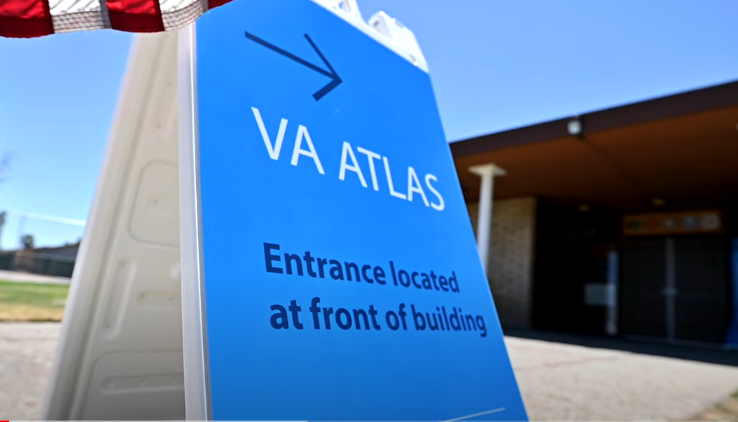
You may qualify for travel reimbursements for video telehealth visits at ATLAS (Accessing Telehealth through Local Area Stations) sites. Veterans and caregivers who already qualify for travel reimbursements for in-person visits at VA facilities can also request ATLAS travel reimbursement.

If eligible, you can submit claims and supporting documentation, such as receipts, for reimbursement of costs incurred. These costs include mileage traveled with a personally owned vehicle, parking, tolls, and other travel expenses.

Submit your travel claims online through the Beneficiary Travel Self Service System (BTSSS). The portal is the U.S. Department of Veterans Affairs’ quickest way to receive claims and supporting documentation for reimbursement of general health care travel. The portal offers 24/7 access, faster payments, direct deposit, and claims tracking.

To find out whether you are eligible for beneficiary travel benefits and to learn more about BTSSS, visit va.gov/health-care/get-reimbursed-for-travel-pays.

